

*#Name: Atharva satunkar*

*#Roll no: COBB073*



**import** pandas **as** pd **import** numpy **as** np **import** seaborn **as** sns

**import** matplotlib.pyplot **as** plt

**from** sympy **import** Symbol, lambdify



x **=** Symbol('x')



**def** gradient_descent(

function, start, learn_rate, n_iter**=**10000, tolerance**=**1e-06, step_size**=**1

):

gradient **=** lambdify(x, function**.**diff(x)) function **=** lambdify(x, function)

points **=** [start] iters **=** 0

**while** step_size **>** tolerance **and** iters **<** n_iter: prev_x **=** start

start **=** start **-** learn_rate **\*** gradient(prev_x) step_size **=** abs(start **-** prev_x)

iters **=** iters**+**1 points**.**append(start)

print("The local minimum occurs at", start)

*# Create plotting array* x_ **=** np**.**linspace(**-**7,5,100) y **=** function(x_)

*# setting the axes at the centre*

fig **=** plt**.**figure(figsize **=** (10, 10))

ax **=** fig**.**add_subplot(1, 1, 1) ax**.**spines['left']**.**set_position('center') ax**.**spines['bottom']**.**set_position('zero') ax**.**spines['right']**.**set_color('none') ax**.**spines['top']**.**set_color('none') ax**.**xaxis**.**set_ticks_position('bottom') ax**.**yaxis**.**set_ticks_position('left')

*# plot the function*

plt**.**plot(x_,y, 'r')

plt**.**plot(points, function(np**.**array(points)), '-o')

*# show the plot*

plt**.**show()



function**=**(x**+**5)**\*\***2 gradient_descent(

function**=**function, start**=**3.0, learn_rate**=**0.2, n_iter**=**50

)

The local minimum occurs at -4.999998938845185

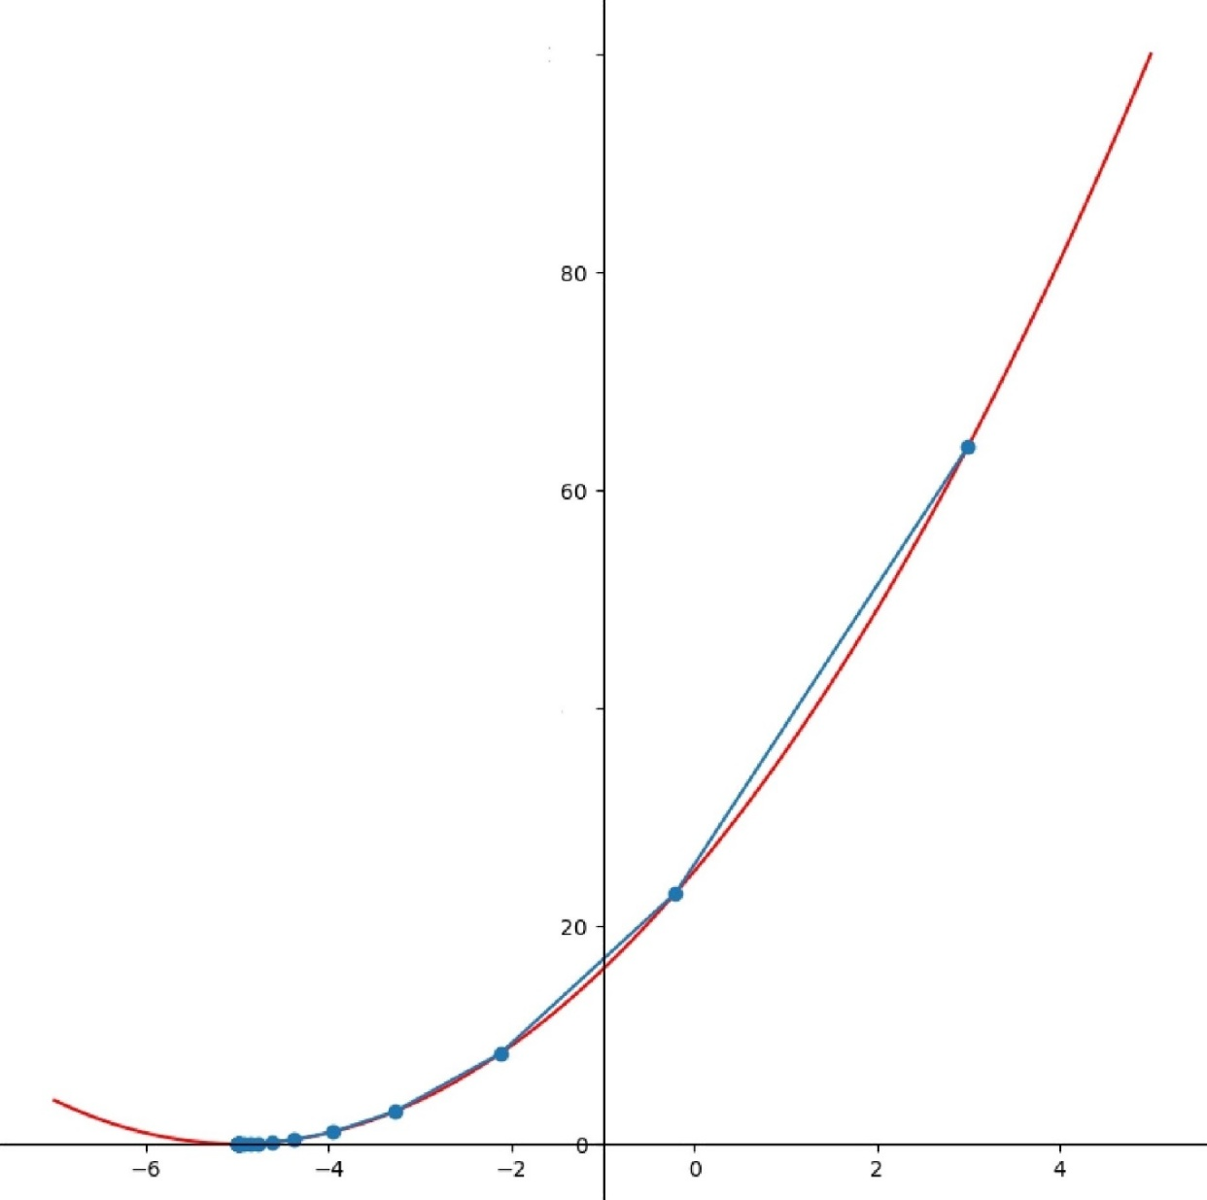

lDO

4D

Loading [MathJax]/jax/output/CommonHTML/fonts/TeX/fontdata.js